2017年国际免疫毒理与安全评价培训班
（第二轮通知）
“2017年国际免疫毒理与安全评价培训班”将于2017年10月11-13日在上海举办。培训班由美国毒理学院（American College of Toxicology ，ACT）和中国毒理学会联合主办，国家上海新药安全评价研究中心和中国药理学会药物毒理专业委员会共同承办。
美国毒理学院（ACT）是一个国际上享有良好声誉，以继续教育和专业培训著称的非盈利学术团体，ACT的培训老师和工作人员均为志愿者，通过共享自己的专业知识和丰富经验提供国际一流的继续教育培训。此次培训班所有演讲嘉宾均来自ACT。
中国毒理学会是中国科学技术协会所属国家一级学会、是国内毒理学科技界的最高学术团体。学会以服务于广大毒理学科技工作者，促进毒理学科学技术的繁荣和发展，促进中国毒理学科技人才的成长和提高为宗旨。学会目前有26个专业委员会、13000余名注册会员，152个团体会员单位。
此次培训班将针对药物的免疫毒性评价方法和临床前评价热点问题，邀请在相关领域有丰富实践经验的国内外知名专家学者，对免疫毒性评价的国内外现状、问题、试验设计和方法以及国内外相关指导原则进行详细的讲解，对研究者和评价者有重要参考价值。除了讲解和回答问题外，会议还将专门安排案例分析与讨论，由国内外专家讲述介绍实例、解答参会人员实践中碰到的问题，讨论提出实际解决方案，以便参与者不仅能很好的消化和掌握培训内容，而且解决实际工作中的一些疑难。
会议期间还将举办实验动物设施设备、科研仪器设备、软件以及其他科技产品等科技展览，在参会的同时了解这些行业的前沿与发展。同时，主办和承办单位欢迎生物和医药科技企业、厂家等参展，加深对客/用户的了解和交流。
本次培训的语言为英语或中文，培训幻灯为中、英文，会议现场拟配备同声传译，讨论阶段有专业人员协助翻译。我们诚挚地邀请从事药物非临床评价的研究人员及相关管理人员、产品研发企业的项目管理和研究人员共赴上海参加此次难得的国际一流继续教育和研修培训和盛会。

- 时间及地点：
时间： 2017年10月11日至10月13日，会期2天半
地点：上海淳大万丽酒店（准五星）
上海市迎春路719号 （见附件3：交通指南）
- 会议日程安排
2017年10月10日下午： 注册报到
2017年10月11日全天： 培训报告
2017年10月12日全天： 培训报告
2017年10月13日上午： 培训报告
详细的会议议程见附件1。

三、会议报名
1、会议回执报名：请填写报名回执并发邮件或传真至会务组（会务组联系方式见后）：
2、链接和二维码报名：通过报名链接http://meeting.ai-shu.com/Participants/Register报名或扫描二维码报名。
参会报名截止到2017年09月30日。
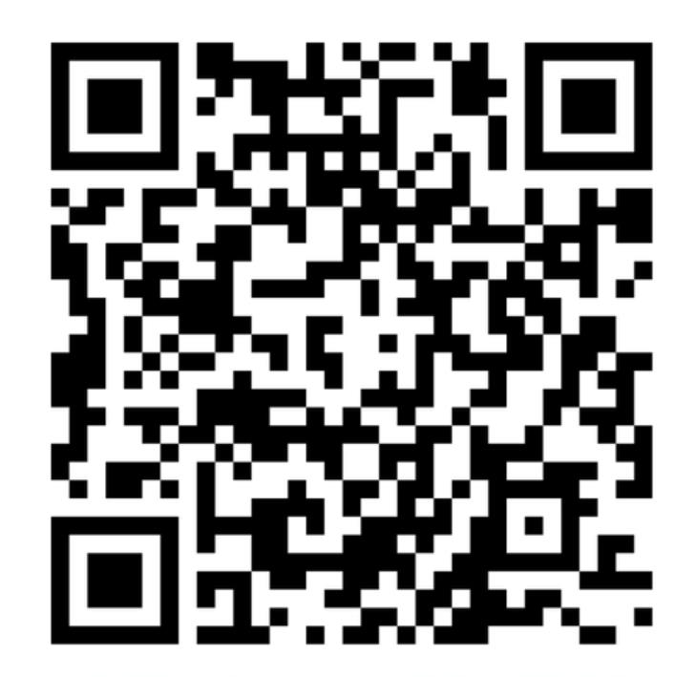

序号 | 参会类型 | 网上缴费  （8月30日前） | 现场缴费
1 | 会员 | 2400元 | 2600元
2 | 非会员 | 2600元 | 2800元
备注：会员指主办方、承办方学会会员，需提供会员证原件或复印件。

会议注册费包括会务费、资料费、讲课费、培训证书、会议期间餐饮（11号-12号晚餐、11号-13日午餐）等费用。由中国毒理学会统一开具增值税普通发票。
缴费方式（网上转账和支付宝转账请务必备注姓名和单位）：
1、网上转账：
开户名：中国毒理学会
开户银行：中国工商银行北京市分行永定路支行
帐号：0200004909014450531
2、报到时缴纳注册费（现金/支付宝）


四、酒店预订
序号 | 酒店名称 | 单间 | 标间
1 | 淳大万丽酒店 | 1000元（含单早） | 1000元（含双早）
2 | 宜必思酒店 | 400元（含单早） | 400元（含双早）
凡在2017年09月15日前注册并缴纳注册费者，可以保证在会场酒店的住宿预订安排；09月15日之后交费注册的概不保证。

五、如需咨询会议相关信息，可联系：
联系人1：
刘丹丹（国家上海新药安全评价研究中心）
联系电话：021-60211990
传真： 021-50801259
电子邮箱：ddliu@ncdser.com
联系人2：
陈丽（国家上海新药安全评价研究中心）
联系电话：021-60211999-3106
传真： 021-50801259
电子邮箱：lchen@ncdser.com
联系人3：
李娜（国家上海新药安全评价研究中心）
联系电话：021-60211999-3135
传真： 021-50801259
电子邮箱：nli-2@ncdser.com

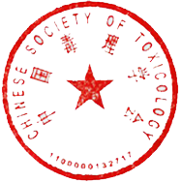
主办方：
American College of Toxicology （ACT）
中国毒理学会

承办方：
国家上海新药安全评价研究中心
中国药理学会药物毒理专业委员会

嘉宾介绍：
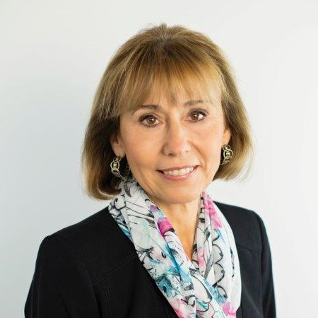
Florence G. Burleson, MSM, Ph.D, has worked at the National Institute of Environmental Health Sciences as a guest researcher, at Procter and Gamble as a contractor for Advanced Tissue Sciences, Inc., and is presently at Burleson Research Technologies, Inc. (BRT). Dr. Burleson is co-founder of BRT where she currently serves as Executive VP and Senior Director of Nonclinical Studies.Dr. Burleson is a member of ACT and SOT. She was elected to the ACT Outreach committee in 2013 and ACT Council in 2016. Dr. Burleson served as ACT representative and as Incoming Chair, Chair, and Past Chair of the Scientific Liaison Coalition (SLC), a coalition of societies to increase the impact of the science of toxicology to improve public health. She is also a member of Editorial Board of the International Journal of Toxicology.


Gary R. Burleson, Ph.D, his background includes clinical experience at Milwaukee County General Hospital, government regulatory experience at the USEPA, and pharmaceutical experience in drug discovery at Procter & Gamble. He cofounded Burleson Research Technologies, Inc. (BRT) in 1996. He is currently President and CEO of BRT, and is an Adjunct Professor at North Carolina State University. He is Senior Editor of Methods in Immunotoxicology, Volumes 1 and 2; a member of the editorial board of the Journal of Immunotoxicology; Science Review Board, US EPA; and is past president of the Immunotoxicology Discussion Group (IDG). He has served as Chairman, Membership Committee and President of the Immunotoxicology Specialty Section, SOT; Conference Chair, Immunotoxicology V Meeting; Organizer, Continuing Education Course entitled “Immunotoxicology,” for 19th Annual Society of Toxicologic Pathology Meeting.

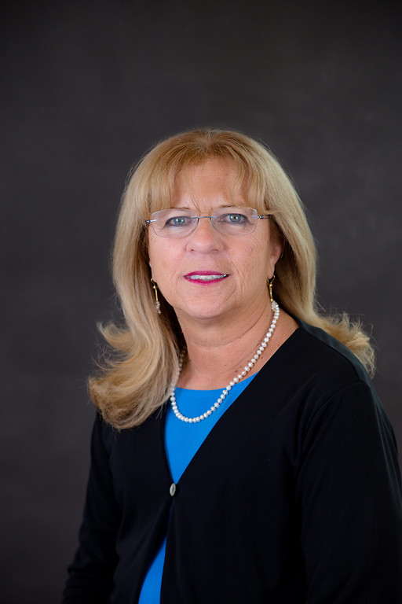
Hanan Ghantous, Ph.D, DABT, joined the US Food and Drug Administration as a pharmacology/toxicology reviewer in 2001, and since 2007 she has been the Pharmacology/Toxicology supervisor at the Division of Antiviral Products, Center for Drug Evaluation and Research. Dr. Ghantous has presented at national and international scientific and regulatory meetings, has served on several US FDA committees, has been involved in writing Guidance documents and has represented the Agency at various public forums. Dr. Ghantous has been a member of the Society of Toxicology since 1989 and the American College of Toxicology since 2000. She served on the Continuing Education Committee of the Society of Toxicology (2010–2013). Dr. Ghantous is one of the founders of the Biotechnology Specialty Section and served as a VP- elect, VP, President and past president of the specialty section (2010-2013). She also served as a member of the Board of Directors of the American Board of Toxicology (2010–2014) and was the president of the board for 2013-2014. She also served on council of the American College of Toxicology (2011-2013) and as VP- elect, VP, President and past president for the American College of Toxicology (2014-2017).

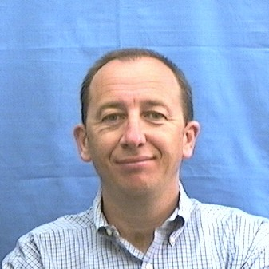
Hervé N. Lebrec, Ph.D, DABT, received a doctorate in Pharmacy and a PhD degree in Toxicology from the University Paris XI in 1992 and continued his training as a postdoctoral fellow at the USEPA in Research Triangle Park in 1992 and 1993. He then occupied Faculty positions at the School of Pharmacy Paris XI until 1999. Dr Lebrec’s career in the pharmaceutical industry began in 2000 at 3M Pharmaceuticals. In 2006, he joined the toxicology department at Amgen, where he currently is a Scientific Director at the South San Francisco site in California and works as a Lead for both small molecule-, biologics- and cellular therapy-based projects. He currently co-chairs the immunotoxicology technical committee (ITC) of HESI.

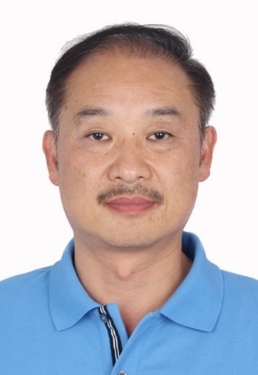
Huaizhong Hu, Ph.D, DABT, serves currently as the vice president of Preclinical Development at CANbridge, Beijing. Prior to CANbridge Dr. Hu spent 10 years at Covance Laboratory and held senior scientific positions as Toxicology Senior Study Director, Immunotoxicology Lead Scientist at Covance U.S. and most recently Early Development Scientific Director at Covance Shanghai. Dr. Hu was a Lee Kuan Yew Research Fellow and Principal Investigator at the Department of Microbiology, Faculty of Medicine at National University of Singapore. He received his Medical Degree from West China University of Medical Sciences and subsequently practiced for 3 years in Clinical Immunology at Huaxi University Hospital. He was a Postdoctoral Fellow in immunology and toxicology at the NIH where he successfully cloned and functionally evaluated a recombinant immunotoxin that has been developed and tested in a Phase II clinical trial for skin T cell lymphoma. He co-authored over 50 publications in peer-reviewed international journals and is an inventor on close to 20 U.S., Europe and China issued or pending patents.

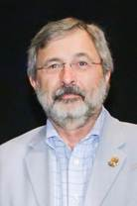
Kenneth L. Hastings, Ph.D, DABT, Fellow A.T.S., received his Doctor of Public Health degree from the School of Public Health, University of North Carolina at Chapel Hill, in 1987. Dr. Hastings then served as a US Peace Corps Volunteer in Fiji under the Permanent Secretary for Health. Dr. Hastings served on numerous committees and working groups while at FDA, including lead representative for CDER/FDA on the ICCVAM validation of the murine local lymph node assay and as lead negotiator on ICH S8 (Immunotoxicology Evaluation of New Drugs). Dr. Hastings served as President of the American Board of Toxicology and has numerous publications, included editor of books on use of mini-pigs in biomedical research and international standards for nonclinical safety evaluation of medical products. Dr. Hastings is currently an independent consultant specializing in toxicology studies in drug development.
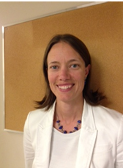
Marie-Soleil Christin-Piché, Ph.D, is the Scientific Director of the immunology group at Charles River Montreal. She has been with Charles River for over 8 years and currently manages a group of scientists working on small molecules, biotherapeutics and vaccines in several different areas. Her expertise is in the areas of biotherapeutic drug safety and immunotoxicology, and her group assesses the effects of drugs on the immune system and specializes in pre-clinical and clinical development. Dr. Marie-Soleil Piché received her Bsc in microbiology and immunology from McGill University, a Masters of Science in Immunotoxicology from the Armand Frappier Institute, and her PhD in Autoimmunity from the University of Montreal. Dr. Marie-Soleil Piché is an active member of the ILSI/HESI Immunotoxicology Technical Committee.

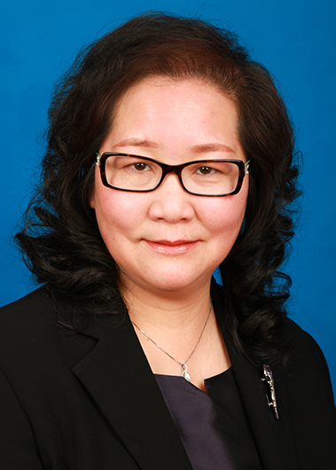
Jing Ma, Ph.D, director of National Shanghai Center for New Drug Safety Evaluation and Research. From 2003 to 2004, she went to University of Alabama at Birmingham as visiting scholar. She is Executive Council Member and Vice Executive Secretary
of Chinese Society of Toxicology, and as the committee member of Toxicology and Drug Evaluation Committee in CSOT, Director of the Toxicology Committee in Chinese Society of Pharmacology, Vice President of Shanghai Pharmaceutical Society, Director of the Toxicology Committee in Shanghai Society of Pharmacology, Council member of Pharmacology Professional Committee in Shanghai Pharmaceutical Society. Dr. Ma serves as a senior GLP inspector of CFDA, and a panel member of CFDA CDE reviewer and EPA reviewer, expert for chemical environmental management in Ministry of Environmental Protection of China. She also served as member of the Editorial Board for "Chinese Journal of Pharmaceuticals", "Chinese Pharmacological Bulletin", "Chinese Adverse Drug Reactions Journal".

附件1：会议议程
Session 1 Oct.11 AM
Immunological Concepts – Provide an Understanding of Basic Immunological Concepts Relevant to Immunotoxicological Evaluations and Testing./免疫学概念 - 了解与免疫毒理学评价和测试相关的基本免疫学概念
08:30-08:50 | Introduction to Course/开幕致辞
08:50-09:30 | Overview of the Immune System/免疫系统的概述  Huaizhong Hu（Canbridge）
09:30-10:10 | Innate Immunity/先天免疫  Huaizhong Hu（Canbridge）
10:10-10:30 | Break/茶歇
10:30-11:10 | Cell-mediated Immunity/细胞介导的免疫  Huaizhong Hu（Canbridge）
11:10-11:50 | Humoral Immunity/体液免疫  Huaizhong Hu（Canbridge）
11:50-12:10 | Q&A/问答
12:10-13:30 | Lunch Break/午餐
Session 2 Oct.11 PM
Immunotoxicology – Define Immunotoxicology within the Context of Immune Dysfunction along with Root Cause and Consequences/免疫毒理学—在免疫功能障碍中的根源和后果
13:30-14:10 | Immunotoxicology and Immune Dysfunction/免疫毒理与免疫功能障碍  Gary Burleson(Burleson Research Technologies)
14:10-14:50 | Immune Suppression/免疫抑制  Gary Burleson(Burleson Research Technologies)
14:50-15:10 | Break/茶歇
15:10-15:50 | Hypersensitivity/过敏症  Florence Burleson(Burleson Research Technologies)
15:50-16:30 | Immune Enhancement and Autoimmunity/免疫增强和自身免疫  Florence Burleson(Burleson Research Technologies)
16:30-17:00 | Q&A/问答
Session 3 Oct.12 AM
Tools and Techniques – Present Immunotoxicity Testing Tools and Techniques, Including Advantages and Limitations /工具和技术—描述免疫毒性测试工具和技术，包含优势和局限性
08:30-09:10 | Non-functional Tests/ 非功能性测试  Marie-Soleil Christin-Piché(Charles River )
09:10-09:50 | TDAR and Cytokine Release Assays/ TDAR和细胞因子释放试验  Hervé Lebrec (Amgen)
09:50-10:10 | Break/茶歇
10:10-10:50 | Innate and Cell -mediated Immunity/先天免疫和细胞介导免疫  Gary Burleson(Burleson Research Technologies)
10:50-11:30 | Cell-based Assays and Additional Tests/基于细胞的测试和附加测试  Florence Burleson(Burleson Research Technologies)
11:30-12:00 | Q&A/问答
12:00-13:30 | Lunch Break/午餐
Session 4 Oct.12 PM
Study Design and Regulatory Considerations – Present Immunotoxicology Study Designs and Testing Paradigms through Case Studies /试验设计和法规方面的考虑——结合案例来讲述免疫毒理学试验设计和测试模型以及相关的国际监管法规的注意事项
13:30-14:20 | Immunotoxicity Testing in Drug Development/药物开发中的免疫毒性测试  Hervé Lebrec (Amgen)
14:20-15:10 | Immunotoxicology Study Designs and Approaches/免疫毒理学研究设计和方法  Marie-Soleil Christin-Piché(Charles River )
15:10-15:30 | Break/茶歇
15:30-16:30 | Regulatory Immunotoxicology/ 免疫毒理学的国际法规要求  Kenneth Hastings (Hastings Toxicology Consulting LLC)
16:30-17:00 | Q&A/问答
Session 5 Oct.13 AM
Study Design and Regulatory Considerations – Present Immunotoxicology Study Designs and Testing Paradigms through Case Studies /试验设计和法规方面的考虑——结合案例来讲述免疫毒理学试验设计和测试模型以及相关的国际监管法规的注意事项
08:30-09:10 | Regulatory Requirements in China/中国的免疫毒理学的法规要求  CFDA (Invited)
09:10-09:50 | Relationship Between Immunogenicity and Preclinical Efficacy and Safety Evaluation/免疫原性与临床前药效及安全性评价的关系  Jing Ma (NCDSER)
09:50-10:10 | Break/茶歇
10:10-11:40 | Case Studies Panel Discussion /案例分析及讨论  All Speakers

附件2：参会回执
请完整填写以下回执并于2017年09月30日前将回执发送至： meeting@ncdser.com
（请详细填写下列信息以便于制作会议通讯录，请最好提供手机，以便有问题及时联系。）

姓名 |  | 职务/职称 | 性别
Email
单位名称
联系电话（手机）
地址及邮编
开票信息*
是否住宿 (请打勾) | 是：淳大万丽酒店 ( ) 宜必思酒店 ( )  单住 ( ) 合住( )  入住时间( ) 离开日期( )  否： ( )
*会务组将根据回执上的开票信息开具发票，并根据地址会后邮寄发票，请务必确保开票信息和地址的准确性。

附件3：交通指南
公共交通乘车指南：地铁9号线至杨高中路站3号口出，步行约730米到达酒店。地铁2号线至上海科技馆站6号口出，步行1.6公里到酒店。从虹桥机场、浦东机场以及各火车站均可直接或转接地铁2号线或9号线，亦可直接乘坐出租车到达酒店。
以下为各起点换乘指南和直接乘坐Taxi的费用：

（1）上海火车站（23点前Taxi费约39元，23点后约52元）
换乘指南：地铁4号线至世纪大道站，同站换乘9号线至杨高中路站3号口出，步 行730米到达酒店。
（2）上海南站 （23点前Taxi费约54元，23点后约71元）
换乘指南：地铁3号线至宜山路站，同站换乘9号线至杨高中路站3号口出，
步行730米到达酒店。
（3）虹桥机场（23点前Taxi费约75元，23点后约100元）
换乘指南：地铁10号线至老西门地铁站，同站换乘8号线至陆家浜路站，同站换乘9号线至杨高中路站3号口出，步行730米到达酒店。
（4）虹桥火车站（23点前Taxi费约98元，23点后约129元）
换乘指南：地铁2号线直达世纪大道，同站换乘9号线至杨高中路站3号口出，步行730米到达酒店。
（5）浦东机场（23点前Taxi费约131元，23点后约172元）
换乘指南：地铁2号线地铁2号线东延伸段 （广兰路方向）至广兰路站 ，同站换乘2号线（徐泾东方向）至上海科技馆6号口出，步行1.6公里到达酒店。
